**CV Finals**

**Generative Models (AE, VAE, GANs, Diffusion Model)**

**Autoencoder:**

An autoencoder is a type of artificial neural network used for unsupervised learning, where it learns to reconstruct input data. This is achieved via a bottleneck layer, a compressed representation of the input.

The basic architecture of an autoencoder comprises three key components:

**1. Encoder:** Responsible for reducing the input to a compressed representation.

**2. Decoder:** Reconstructs the input from the compressed representation.

**3. Reconstruction Layer:** Found at the output of the decoder, it aims to minimize the difference between the input and the reconstructed output.

**Visual Representation**

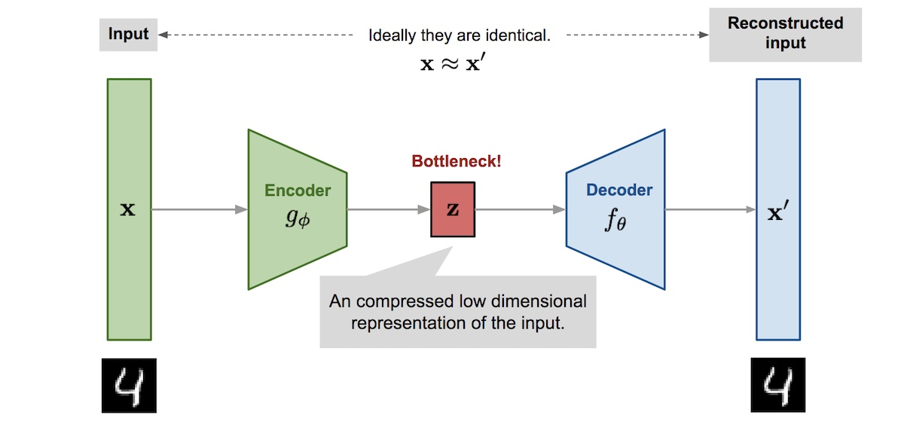

**1. Autoencoder Architecture**

**Key Components**

**1. Encoder**: Combines a series of layers, typically feedforward neural network layers, to transform input data into a lower-dimensional representation. This transformation is the latent space and is often learned via techniques like backpropagation.

* **Input:** The original data, most commonly flattened in vector form.
* **Layers:** Multiple, can include dense, convolutional, or recurrent layers.
* **Output:** Represents the latent space, usually a 1D or 2D vector.

**2. Latent Space:** It is a lower-dimensional space where the most salient features of the input data are represented. Its dimensionality can be controlled, but specific methods such as PCA or t-SNE are required for visualization.

**3. Decoder:** Reverse of the encoder, the decoder uses one or more feedback connections, sometimes referred to as "transposed" layers, to reconstruct the input. The number of neurons in the final layer matches the dimensionality of the input data.

* **Input:** The compressed representation from the latent space.
* **Layers:** Reversed structure of the encoder layers.
* **Output**: Reconstructed input, usually homogeneous with the input data.

**4. Reconstruction Loss Layer**: Positioning of this layer is crucial; the optimization process aims to minimize the difference between the input data and the reconstructed output.

* **Loss: Often Mean Squared Error (MSE) or other appropriate metrics.**
* **Output: Compares the reconstructed input with the original input to quantify the reconstruction error.**
* 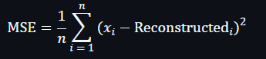

**Usage in Feature Learning**

Although initially designed for unsupervised learning and dimensionality reduction, autoencoders have demonstrated effectiveness in various tasks, including:

* **Denoising:** By training on noisy data, the autoencoder learns to remove noise.
* **Anomaly Detection**: It can identify outliers by detecting data points that are difficult to reconstruct.
* **Feature Learning**: It excels at learning salient representations or features in an unsupervised manner, which can then be used in supervised learning pipelines.

**2. How do autoencoders perform dimensionality reduction?**

Autoencoders are neural networks that can perform unsupervised learning and nonlinear dimensionality reduction. By leveraging encoder and decoder components, they can learn effective, often nonlinear, data representations.

Many conventional dimensionality reduction methods, such as Principal Component Analysis (PCA), are linear. Autoencoders, by contrast, can learn more complex, nonlinear data structures.

Autoencoders minimize a reconstruction loss that measures the difference between the input data and the output of the decoder. This process mathematically aligns with reducing reconstruction error in lower-dimensional subspaces.



**3. Drawbacks of AE**

* **Limited Generative Capabilities**: Traditional autoencoders don't learn a continuous latent space suitable for generating new, diverse samples. The decoder struggles to produce realistic or meaningful outputs from random points in the latent space.
* **Overfitting:** They can easily memorize the training data rather than learning underlying patterns, which can lead to poor generalization on unseen data.
* **Sensitivity to Noise:** Autoencoders can be sensitive to noise and artifacts in the training data, potentially learning to reconstruct these instead of the underlying signal.
* **Difficulty with Complex Data:** They might struggle to capture complex relationships in high-dimensional or structured data, resulting in poor reconstruction or feature extraction.

**4. Why VAEs:**

* **Probabilistic Latent Space:** VAEs encode inputs into a probability distribution in the latent space, which provides a more flexible and continuous representation.
* **Generative Capabilities**: This probabilistic approach allows VAEs to sample from the latent space and generate new data points that are similar to the training data.
* **Disentangled Representations**: VAEs are designed to learn disentangled representations in the latent space, meaning that different latent dimensions correspond to different aspects of the input data.
* **Overcoming Overfitting**: The regularization imposed by VAEs during training helps prevent overfitting and ensures that the learned latent space is well-structured and informative.
* **Improved Reconstruction and Feature Extraction**: VAEs can better capture complex relationships in the data, leading to improved reconstruction and feature extraction capabilities

**5. AutoEncoder Questions/important points:**

**1)** Autoencoders are a supervised learning technique?

**Ans: False:** Autoencoders are an unsupervised learning technique**.2)** Autoencoder’s output is exactly the same as the input?

**Ans:** **False:** The output of an autoencoder are indeed pretty similar, but not exactly the same.

**3)** One way to implement under complete autoencoder is to constrain the number of nodes present in hidden layer(s) of the neural network.

**Ans: True:** Having less number of nodes in hidden layer(s) limits the amount of information that can flow through the network.

**4)** Autoencoders are capable of learning nonlinear manifolds (a continuous, non-intersecting surface.)

**Ans: True:** Autoencoders can be viewed as a generalization of PCA (another dimensionality reduction method which discovers lower dimensional hyperplane

**Variational Autoencoder (VAEs):**

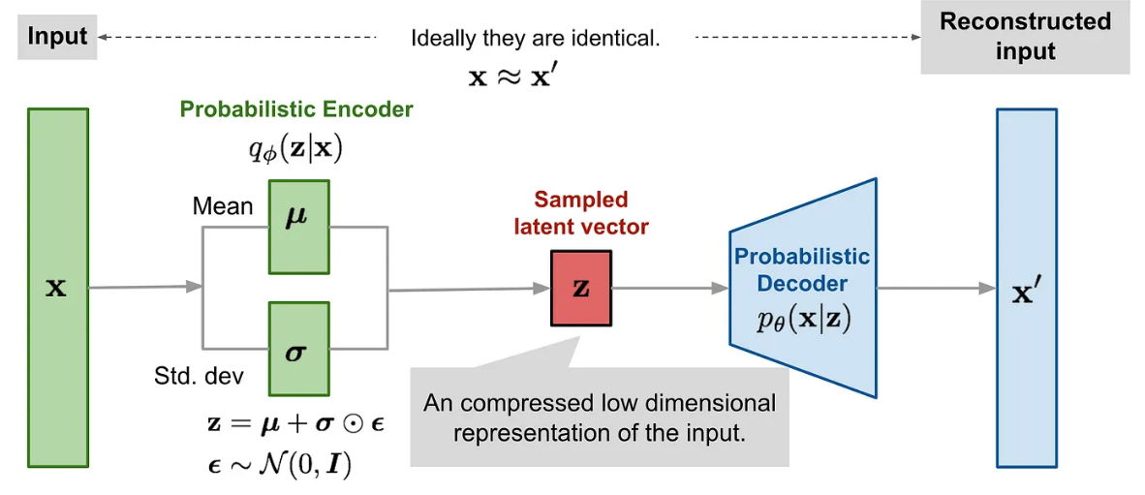

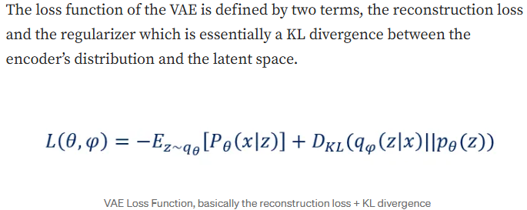

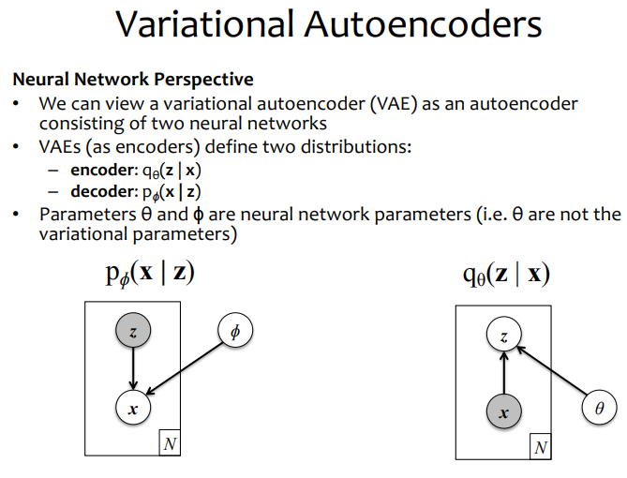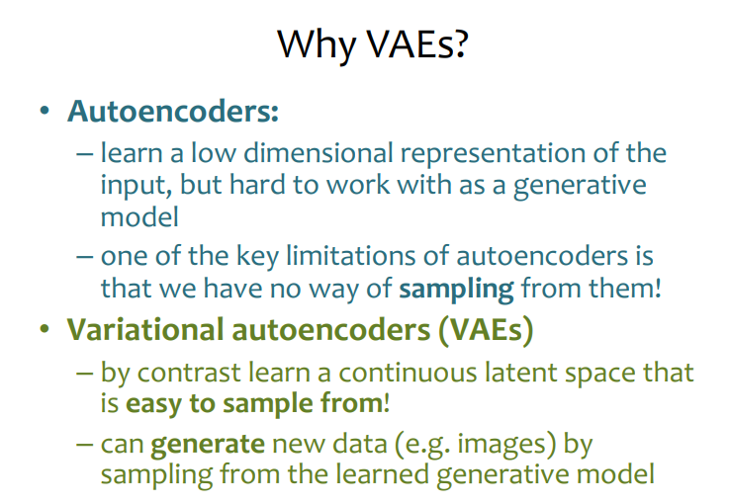

**Reparameterization Trick**

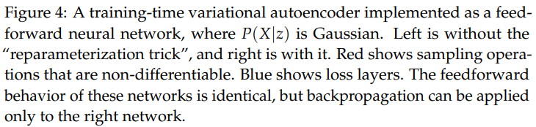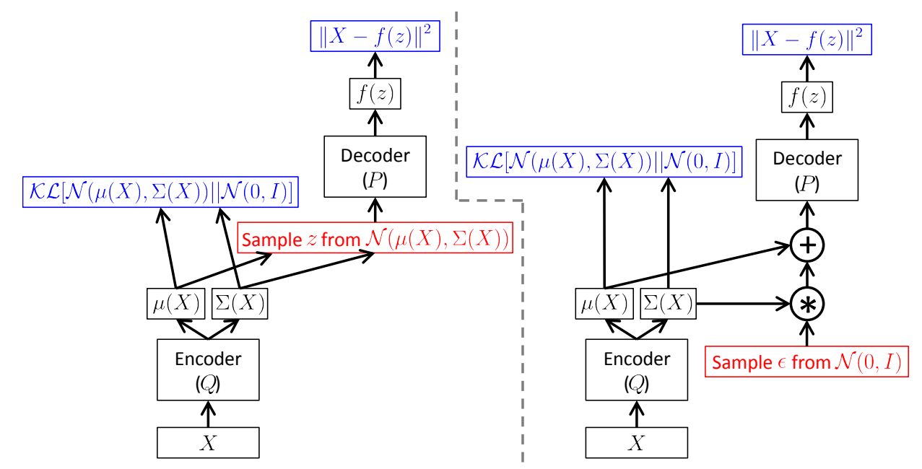

**Questions on VAEs:**

**1**) **Briefly explain the working principle of Variational Autoencoders (VAE) and why they hold an important place in generative models.**

**Ans:** **Working Principle**: Variational Autoencoders (VAE) operate through two main components: an encoder and a decoder. The encoder maps input data to a distribution in the latent space, and the decoder samples from this latent space in an attempt to reconstruct the input data. During this process, VAEs are trained by minimizing the reconstruction error and the KL divergence between the latent space distribution and some prior distribution (usually Gaussian).

**Importance:** The importance of VAEs in generative models lies in their ability to learn and simulate complex data distributions. This means that VAEs can be used not just for data reconstruction but also for generating new, training-data-like data points. Moreover, this capability of VAEs is highly valuable for tasks such as unsupervised learning, semi-supervised learning, and feature extraction, making them a significant tool in both research and application contexts.

**2) Calculation Problem**: **Consider a simplified VAE model, where the reconstruction loss is the squared error between a data point x and its reconstruction x̂, and the KL divergence measures the difference between the distribution of the latent variable z and the standard normal distribution. Given a data point x=5, its reconstruction x̂=4, the mean μ=0, and variance σ²=1 of the latent variable, calculate the loss for this data point.**

**Ans**: The specific calculation process is as follows:

**Reconstruction loss**: (x — x̂) ² = (5–4)² = 1

**KL divergence**: 1/2 × Σ (1 + log (σ²) — μ² — σ²). For the given μ=0 and σ²=1, the KL divergence calculates to 1/2 × (1 + 0–0–1) = 0.

**Total loss: Reconstruction loss + KL divergence** = 1 + 0 = 1.

**Explanation**: In this simplified example, the total loss consists of the reconstruction loss and the KL divergence. The reconstruction loss measures the difference between the reconstructed data and the original data, while the KL divergence measures the difference between the distribution of the latent variables and the prior distribution. In this case, the total loss is 1.

**3**) **Explain what the role of the reparameterization trick in VAE is and why this trick is crucial for training the model.**

**Ans: Role:** The reparameterization trick enables the training process of VAE to be conducted through optimization algorithms like Stochastic Gradient Descent (SGD). Specifically, it allows for the derivation of the sampling process of random variables during backpropagation, thereby updating the model parameters.

**Importance:** This trick is crucial for model training because it addresses the infeasibility of directly deriving the random sampling process. By introducing a derivable parameterized noise, the reparameterization trick ensures that the entire model can still be trained end-to-end. This is necessary for learning complex data distributions, as it guarantees that the model can be effectively learned through standard backpropagation algorithms**.**

**4) When training a VAE model, you may encounter issues where the model fails to learn useful information, resulting in blurred or unclear generated images. List at least two methods to address this issue.**

**Ans:** Increase model complexity: Adding more layers or increasing the number of neurons per layer can enhance the model’s learning capability.

Adjust the weights in the loss function: Increasing the weight of the reconstruction loss relative to the KL divergence loss can encourage the model to prioritize reconstruction quality, resulting in clearer images.

**5)** **Explain why it is necessary to adjust the weight of the KL divergence term in the loss function during the training of a VAE? What is the impact of this adjustment?**

**Ans: Explanation:** Adjusting the weight of the KL divergence term in the loss function during VAE training is necessary to balance the reconstruction error and regularization of the latent space. If the weight of the KL divergence is too high, the model might overly emphasize matching the prior distribution of the latent space, neglecting the quality of data reconstruction, leading to overly vague or less diverse generated data. Conversely, if the reconstruction error’s weight is too high, the model might overlook the structure of the latent space, leading to overfitting.

**Impact:** The impact of this adjustment is a balance between the quality and diversity of the generated data. Proper adjustment can enable VAEs to better learn the distribution of data while maintaining the continuity and smoothness of the latent space, thereby generating data that is both clear and diverse.

**6) Case Study Problem: Consider the application of VAEs in image denoising. Describe how VAEs can be used to remove noise from images and explain the underlying principle.**

**Ans:** **Description**: VAEs can remove noise from images by learning the latent representations of those images. During the training phase, the model is trained to reconstruct the mapping from noisy images to clean images. The encoder part learns to extract latent features from noisy images, while the decoder learns how to reconstruct noise-free images from these latent features.

**Principle:** The principle behind this process is that VAEs can capture the latent distribution of data. Through training, VAEs learn to ignore the effects of noise and focus on the essential content of the images. Therefore, when the model encounters new noisy images, it can effectively reconstruct clear images, achieving the purpose of denoising.

**7) What advantages do VAEs have in feature extraction? Please explain how these advantages can help solve problems in actual application scenarios.**

**Ans:** **Advantages:** The advantages of VAEs in feature extraction include their ability to learn deep, abstract representations of data and their understanding of the data’s generative distribution. This means VAEs can not only capture the main features of data but also explore the latent space to discover relationships and differences between data points.

**Application Scenario:** In recommendation systems, VAEs can be used to extract feature representations of users and items, thereby predicting user preferences for unknown items. By learning about user behavior and item attributes, VAEs can reveal patterns hidden behind the data, helping to improve the accuracy and diversity of recommendations.

**Problem-Solving:** In this scenario, VAEs, by extracting deep features and understanding the distribution of user behavior, can more accurately match user preferences with item characteristics. This not only improves user satisfaction but also enhances the system’s personalized recommendation capabilities.

**8) What are the advantages and limitations of VAEs and GANs (Generative Adversarial Networks) in the field of generative models? Discuss potential points of fusion or areas for mutual learning between these two types of models in the future.**

**Ans: VAEs** excel in their stable training process and good modeling capability for the latent distributions of data but may not match GANs in generating sharp, high-quality images. The limitations of VAEs primarily stem from the assumed distribution form, which may restrict the model complexity and expressiveness.

GANs are outstanding in producing high-quality, realistic images, but their training process can be unstable and challenging to manage. GANs’ limitations include potential for mode collapse, where the model fails to capture the full diversity of the data.

**Potential Fusion Points:** Future models could explore combining VAEs’ and GANs’ strengths, such as using VAEs for stable training and deep understanding of data distributions, while leveraging GANs’ ability to generate high-quality outputs. This fusion could lead to models that are both efficient to train and capable of producing highlyrealistic results, opening new avenues for generative models in various applications.

**9) Compare the main differences between Variational Autoencoders (VAE) and Generative Adversarial Networks (GAN) in the task of image generation. Consider their respective advantages and limitations.**

**Ans: Differences in Image Generation Tasks:**

**VAE** generates images by minimizing the reconstruction error and the KL divergence in the latent space, emphasizing the learning and modeling of data distribution. Its advantage lies in providing a continuous latent space, facilitating image interpolation and manipulation. However, images generated by VAEs may be more blurred compared to those generated by GANs.

**GAN** operates through adversarial training, where one network generates images and another network attempts to distinguish generated images from real ones. GAN’s strength is in producing highly realistic images, but its training process can be unstable and may encounter mode collapse issues, leading to a lack of diversity.

**10) Analyze the performance of VAE and GAN in the task of image denoising. Which model is more suited for this task, and why?**

**Ans: Performance in Image Denoising Tasks:**

**VAE** performs better in image denoising because its generative process includes minimizing the reconstruction error, which helps restore clear image details. VAE’s continuous latent space also facilitates learning useful representations from noisy data.

**GAN,** while capable of generating high-quality images, may not perform as well in denoising tasks because its focus is on generating realistic images, not necessarily effectively removing noise from images. **Therefore, VAE might be more suitable for image denoising tasks**, mainly because it can better learn and reconstruct the distribution of data.

**11) Given the characteristics of VAE and GAN, discuss how they might be combined in the future to leverage their respective strengths.**

**Ans: Potential for Combining:**

In the future, VAE and GAN could be combined to utilize the strengths of both. For example, the continuous latent space learned by VAEs could be used to improve the quality of GAN-generated images while avoiding the instability and mode collapse issues of GAN training.

Another way to combine them is to use high-quality images generated by GANs to train VAEs, thereby enhancing the quality of VAE generation. Moreover, the latent space of VAEs could be used for conditional generation in GANs to control specific attributes of the generated images.

**Advantages of Combining:**

Combining VAE and GAN could balance the quality and diversity of generated images while improving the stability and controllability of the model. Such hybrid models hold great potential in various applications, such as image editing, style transfer, and augmented reality

**Generative Adversarial Networks (GAN)**

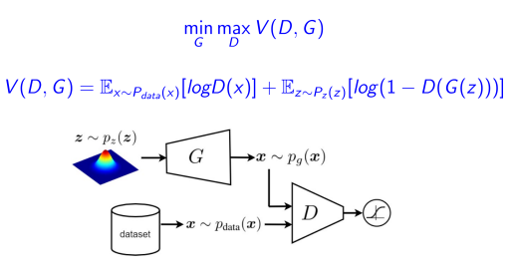

**How GANs Work:**

* **Generator (G):** Creates fake data (e.g., images) from random noise (z).
* **Discriminator (D):** Acts as a detective, trying to distinguish between real data (from a dataset) and fake data (from the generator).
* **Adversarial Training:** The generator tries to fool the discriminator, while the discriminator gets better at detecting fakes. This competition improves both networks over time.

**Loss Function:**



* **Discriminator (D) Goal:** Maximize the probability of correctly classifying real and fake data**.**
* **Generator (G) Goal:** Minimize the discriminator’s ability to detect fake data (i.e., make fake data look real).
* **Optimal Equilibrium:** The best outcome is when the generator produces data so realistic that the discriminator can’t tell the difference (i.e., it guesses randomly with 50% accuracy).



**GAN vs VAE**

|  |  |  |
| --- | --- | --- |
|  | **GANs** | **VAEs** |
| **Core Idea** | * Uses two competing networks: a Generator (G) and a Discriminator (D). * The generator tries to fool the discriminator, while the discriminator tries to detect fake data. * Training is adversarial (a min-max game). | * Uses an encoder-decoder structure. * The encoder compresses input data into a latent space (probabilistic distribution). * The decoder reconstructs data from the latent space. * Training is based on maximizing a lower bound (ELBO) of the data likelihood. |
| **Training Objective** | * Minimax objective * No explicit likelihood modeling—focuses on generating realistic samples | * Maximizes the Evidence Lower Bound (ELBO) * Explicitly models data likelihood but may produce **blurrier outputs** than GANs |
| **Output Quality** | * Generates sharper, more realistic images (better for high-quality synthesis). * Prone to **mode collapse** (limited diversity in outputs). | * Tends to produce **smoother, sometimes blurrier** reconstructions. * Better at capturing **data variability** but may lack fine details. |
| **Latent Space** | * The latent space **(z)** is usually unstructured noise. * Some GAN variants (like **DCGAN, StyleGAN**) learn meaningful latent representations. | * Explicitly learns a **probabilistic latent space** (e.g., Gaussian). * Allows **interpolation** and **controlled generation** via latent variables. |
| **Applications** | * Image generation (e.g., "This Person Does Not Exist"). * Image-to-image translation (CycleGAN, Pix2Pix). * Text-to-image synthesis (StackGAN). * Inpainting, super-resolution, style transfer. | * Used in **semi-supervised learning.** * **Dimensionality reduction** (like PCA but nonlinear). * **Data compression & denoising.** |
| **Stability & Training Difficulty** | * Harder to train due to **instability** (discriminator/generator imbalance). * Suffers from **vanishing gradient**s and **mode collapse.** | * More stable training (no adversarial component). * But may suffer from **posterior collapse** (latent variables ignored). |

**Problem with GANs: Mode Collapse:**

**Definition:** The generator "collapses" to a small set of outputs, ignoring other modes (variations) in the training data.

**Why Does Mode Collapse Happen?**

* **Discriminator Overpowers Generator:**
  + If D becomes too good too fast, G finds it hard to improve and "quits" exploring.
* **Limited Capacity in Generator:**
  + A weak generator may lack the ability to model all modes.
* **Poor Loss Function:**
  + Traditional GAN loss (log (1-D (G (z))) can saturate (stop providing useful gradients).

**How to Fix Mode Collapse?**

**(1) Minibatch Discrimination (Slides 56-61)**

* **Idea:** Force the discriminator to look at **multiple samples at once** (not just one).
* **How?**
  + Compute similarities between samples in a batch.
  + If all generated images are identical, the discriminator penalizes the generator.
* **Result:** Encourages diversity in outputs.

**(2) Unrolled GANs (Slide 62)**

* **Idea:** Let the generator "peek" at future discriminator updates.
* **Why?** Prevents G from overfitting to the current D.

**(3) Experience Replay (Slide 62)**

* **Idea:** Store past generated samples and occasionally replay them to D.
* **Why?** Prevents D from forgetting past modes.

**(4) Modified Loss Functions (e.g., Wasserstein GAN)**

* **Idea:** Replace log(1-D(G(z))) with a more stable loss (e.g., Earth-Mover distance).Let the Loss function be the same but without log
* **Why?** Avoids vanishing gradients.

**(5) Architectural Tweaks (Slide 63)**

* Increase generator capacity.
* Add noise to discriminator inputs.

**Conditional GANs:**

* **Why use :**

A **Conditional GAN (cGAN)** is a modified version of a regular GAN where:

You can **control what the generator creates** (e.g., generate a "cat" instead of a random animal).

Both the **Generator (G**) and **Discriminator (D)** receive **extra information (like labels)** to guide the generation.

**Example:**

**Normal GAN:** You ask for an image → get a random animal.

**Conditional GAN:** You ask for a "cat" → get only cats.

* **New Loss Function:**

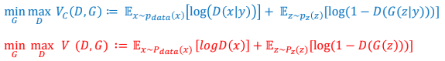

* + **D(x|y):** Checks if real image x matches label y.
  + **G(z|y):** Generates fake images conditioned on label y.
* **Training:** 
  + Feed **label + noise** to Generator → fake image.
  + Feed **label + real/fake image** to Discriminator → classification.
  + Update both networks until G fools D **for the correct label**.

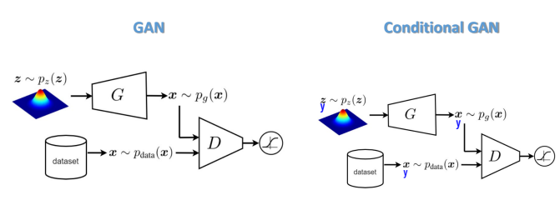

* **Y** shows the condition /labels

**Adversarial Autoencoders (AAE):**

**What?**A hybrid of Autoencoder + GAN that uses adversarial training to shape the latent space.

**How?**

* **Encoder (G):**Compresses input x → latent code z.
* **Decoder:**Reconstructs x from z.
* **Discriminator (D):**Forces z to match a target distribution (e.g., Gaussian).

**Why?**

* Better latent space control than vanilla autoencoders.

**Unsupervised AAE**

**What?**No labels are used. Learns to:

1. Reconstruct inputs (Encoder → Decoder).
2. Make latent z match a prior distribution (e.g., Gaussian) via adversarial training.

**Architecture:**

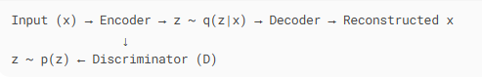

**Supervised AAE**

**What?**Uses labeled data to learn latent codes tied to classes.

**Key Change:**

* Encoder also predicts class labels (y) from x.
* Discriminator ensures z matches class-conditional priors.

**Use Case:**

* Classification tasks with structured latent space.

**Clustering with AAE**

**What?**Unsupervised clustering by learning discrete latent variables.

**How?**

1. Encoder outputs:
   * Continuous z (for reconstruction).
   * Categorical y (cluster assignment).
2. Discriminator ensures y follows a uniform/custom distribution.

**Example:**

* Group MNIST digits into 10 clusters without labels

**Semi-Supervised AAE**

**What?**Mixes labeled + unlabeled data for training.

**How?**

1. For labeled data: Train like Supervised AAE.
2. For unlabeled data:
   * Randomly sample a pseudo-label y from current class distribution.
   * Train encoder to predict y and fool discriminator.

**Use Case:**

* Medical imaging (few labeled scans, many unlabeled ones).

**Dimensionality Reduction with AAE**

**What?**Projects data to low-dimensional space with class info.

**Key Trick:**

* Latent representation = Wᵀy + z
  + Wᵀy: Class-specific projection.
  + z: Noise for variability.

**Advantage:**

* Better than PCA: preserves class structure

**Why AAEs?**

* More flexible than VAEs (no need for tractable likelihoods).
* Controllable latent space via adversarial training.
* Works for all data types (images, text, etc.).

**When to Use:**

**1. Standard AAE (Unsupervised)**

**When to Use:**

* You need **generic data generation** or **anomaly detection** without labels.
* You want to **enforce a specific distribution** (e.g., Gaussian) on latent codes.

**Examples:**

* **Generate new fashion designs** (no labels, just learn the distribution of clothing images).
* **Detect defective products** on a production line (normal vs. anomalous samples).

**Slide Reference:** 80 (Unsupervised AAE architecture).

**2. Supervised AAE**

**When to Use:**

* You have **labeled data** and want to generate class-specific samples.
* You need **latent codes tied to known categories**.

**Examples:**

* **Generate handwritten digits by class** (e.g., only "7"s) for data augmentation.
* **Create synthetic medical scans** (e.g., "tumor" vs. "healthy") to train classifiers.

**Slide Reference:** 86 (Supervised AAE architecture).

**3. Clustering AAE**

**When to Use:**

* You have **unlabeled data** and want to **discover natural groupings**.
* You need **cluster-aware generation** (e.g., create samples per cluster).

**Examples:**

* **Group customer purchase histories** into segments (e.g., "budget shoppers," "luxury buyers").
* **Cluster protein sequences** into functional families (biology research).

**Slide Reference:** 82-85 (Clustering AAE workflow).

**4. Semi-Supervised AAE**

**When to Use:**

* You have **a few labeled examples + lots of unlabeled data**.
* You want to **improve model performance** using unlabeled data.

**Examples:**

* **Diagnose rare diseases** (few labeled scans, many unlabeled ones).
* **Classify social media posts** (limited labeled data, vast unlabeled text).

**Slide Reference:** 88-92 (Semi-Supervised AAE setup).

**5. Dimensionality Reduction AAE**

**When to Use:**

* You need **low-dimensional visualizations** that preserve class structure.
* Traditional methods (PCA, t-SNE) fail to capture non-linear relationships.

**Examples:**

* **Visualize gene expression data** in 2D while keeping cancer subtypes separable.
* **Compress sensor data** from IoT devices for fault detection.

**Slide Reference:** 96 (Dimensionality Reduction formula: z = Wᵀy + noise).

**Diffusion Model:**

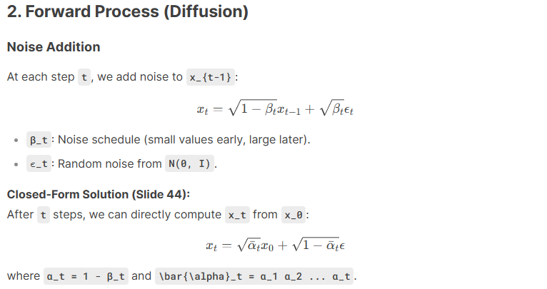

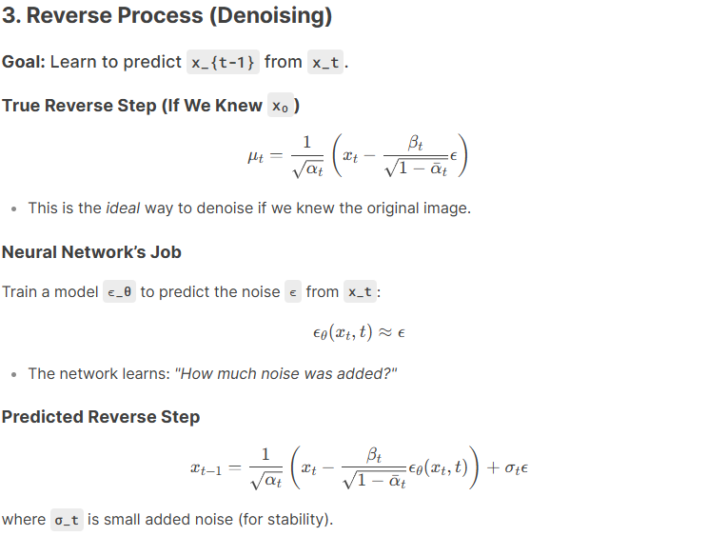

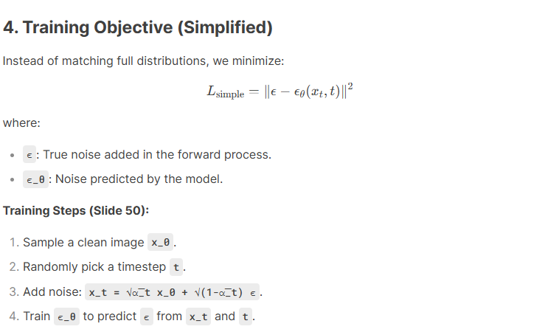

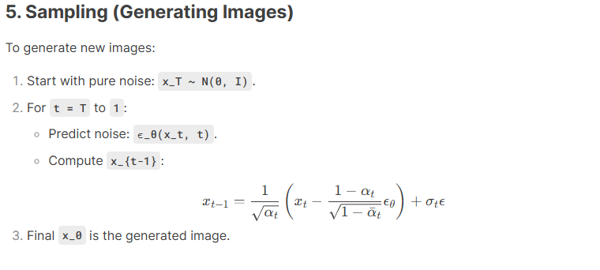

| **Model** | **How It Works** | **Pros** | **Cons** |
| --- | --- | --- | --- |
| **VAE** | Compress → Reconstruct in one step. | Fast training. | Blurry outputs. |
| **GAN** | Generator vs. Discriminator battle. | High-quality images. | Unstable training (mode collapse). |
| **Diffusion** | Step-by-step denoising. | Stable, high-quality generation. | Slower sampling. |

| **Transition** | **Problem in Previous Model** | **Solution in New Model** | **Outcome** |
| --- | --- | --- | --- |
| **AE → VAE** | AEs couldn’t generate new data. | VAE introduced probabilistic latent space (z∼N(μ,σ2)*z*∼*N*(*μ*,*σ*2)). | Enabled sampling from latent space for generation. |
| **VAE → GAN** | VAEs produced blurry outputs. | GANs used adversarial training for sharper images. | Achieved photorealistic image quality. |
| **GAN → Diffusion** | GANs suffered from instability (mode collapse, training difficulties). | Diffusion models replaced adversarial training with stepwise denoising. | Stable training with superior output quality. |

Attention :

Numericals :

